Joint industry paper - Recycling Packaging in practice

The undersigned organisations would like to bring to the attention of the European Commission a joint proposal for a harmonised definition of recyclable packaging as part of the upcoming revision of the Packaging and Packaging Waste Directive (PPWD). To ensure that packaging is not just recyclable but effectively recycled by 2030, we need an ambitious, actionable and forward-looking definition of recyclability, enabling innovations in packaging, infrastructure and recycling technologies. Engaged consumers will also play a key role in ensuring recycling takes place in practice.

Our proposal in a nutshell
- The EU-wide definition of recyclable packaging should not include a recyclability threshold. Any specific recyclability thresholds should instead be set in material- and format-specific Design for Recycling (DfR) guidelines.
- Packaging recyclability must be assessed on the basis of recognised DfR guidelines specific to each material and packaging type. These guidelines should themselves be built on the different guidelines already existing or being developed from across the packaging value chain.
- A dedicated multistakeholder expert committee, in the form of a Technical Committee, should be set up at EU level to define and regularly update (e.g. yearly) recyclability measurement criteria and DfR guidelines per packaging material and type.
- Waste management infrastructure is key to ensure that recyclable packaging is effectively recycled. Infrastructure. Criteria and conditionalities need to be part of the recyclable packaging definition. The geographical scope should be EU-wide to support the development of a true and functioning Single Market for secondary raw materials.

Table of Contents
1. Defining recyclable packaging 2
i.A recyclability threshold in the EU-wide definition of recyclable packaging would be detrimental to the EU sustainability and climate objectives 2
ii.The unintended consequences of the inclusion of a 95% threshold is the EU-wide definition of recyclable packaging 2
iii.The EU-wide definition of recyclable packaging should be actionable, forward-looking and material neutral 3
2. Assessing recyclability 3
i.A dedicated European Technical Committee 3
ii.A one-step Design for Recycling conformity assessment 4
iii.Deploying the appropriate infrastructure 4
Annex I – Non-exhaustive list of examples of packaging formats and applications for which a 95% recyclability threshold is not applicable 6
Annex II - Signatories 9

Defining recyclable packaging

A recyclability threshold in the EU-wide definition of recyclable packaging would be detrimental to the EU sustainability and climate objectives
An actionable and forward-looking definition of recyclability must be technology and material neutral, and foster the co-evolution of innovative packaging, recycling technologies and infrastructure. A packaging can be recycled at scale into a product, material or substance, enabling for innovation in all recycling technologies, including mechanical, organic and chemical recycling.
The draft qualitative definition of recyclable packaging presented during the different stakeholders consultations supporting the revision of the Packaging and Packaging Waste Directive is raising important concerns. The latest version of the definition presented to stakeholders stated that “At least 95% of the unit of packaging shall be recyclable”.
While a level playing field should be ensured between materials, with the objective that all packaging is recyclable by 2030, this 95% recyclability threshold does not account for the different product and material specificities.
- The undersigned organisations are strongly opposed the proposed inclusion of this recyclability threshold in the definition of recyclable packaging as it would generate unintended environmental consequences or lead to the disappearance of an entire segment of packaging that are already being effectively recycled today.
The 95% threshold is not suitable for several types of packaging as it would require increasing the thickness of the main material just to reach this threshold. In several types of packaging, the necessary functional layers and components (inks, surface lacquers, etc.) often represent a percentage above 5%. This would lead to unintended environmental consequences contradicting the key EU objective of minimising packaging waste.
- We therefore recommend not to include any recyclability threshold in the definition of recyclable packaging but instead include any specific thresholds in material- and format-specific Design for Recycling guidelines.
We also call on the European Commission to clarify what constitutes a “unit of packaging”. A “unit of packaging” could be understood as the entirety of a packaging, or each individual component of a packaging. It also raises the question as to whether the proposed 95% recyclability threshold of a unit of packaging is to be understood on a weight or on a volume basis, i.e. if 95% of the unit of packaging should be recyclable, is it 95% of the weight of this unit, or 95% of its volume?

The unintended consequences of the inclusion of a 95% threshold is the EU-wide definition of recyclable packaging
Contradicting the EU sustainability and climate objectives: The inclusion of a 95% recyclability threshold in the EU definition of recyclable packaging would lead to an unnecessary increase of use of resources as for several types of packaging, it would require increasing the thickness of the main material to comply with this threshold. This would also contradict the European Green Deal and EU climate goals: thicker packaging means more packaging placed on the market and an increase of greenhouse gas emissions.
Weakened supplies and increased food waste: Numerous products are currently packed in packaging that would not reach the proposed 95% recyclability threshold. These packaging play a vital role in the safety, accessibility, affordability and availability of food supplies and products across the EU. Packaging formats that are already effectively recyclable today but do not meet the 95% threshold or for which new recycling streams are being developed thanks to new recycling technologies would effectively disappear from the EU market. The removal of these packaging solutions from the market would result in a shortfall in supplies or affordability of food and other products. Furthermore, changing the packaging composition to comply with a 95% threshold could result in modifications to the packaging barrier performance thus affecting food shelf life and resulting in higher food waste and higher greenhouse gas emissions.
Disrupted value chain: Most packaging machines used to fill packaging with goods would be hardly operable with thicker packaging materials, meaning these machines would need to be modified or replaced, entailing costs for economic operators but also significant disruptions in the value chain.
Social and economic impact: If certain packaging applications disappear from the EU market due to the introduction of this recyclability threshold, the EU economy would be impacted as it would lead to the end of an entire segment of the packaging market (flexible packaging) as well as removal of other types of packaging materials and applications, and consequent jobs losses in the packaging value chain.
Annex I of this document provides a list of examples of packaging formats for which a 95% recyclability threshold is not applicable.

The EU-wide definition of recyclable packaging should be actionable, forward-looking and material neutral
The undersigned organisations are putting forward an alternative proposed definition of recyclable packaging, which reads as follows:
- “Recyclable packaging is that which can be effectively and efficiently collected, in line with article 3 (11) and article 11 (1) of the WFD, – by a minimum of 50% of the EU population and with a goal to reach 90% within 5 years –, sorted – meaning the majority of these packaging is oriented into the defined and recognised waste streams for recycling processes – and is capable of being recycled at scale with full transparency on the tonnages recycled and outlets, and with guarantees that the secondary materials produced, in line with Article 6a of the PPWD, are of sufficient quality that they can find end markets to substitute for the use of raw material, and based on the updated guidelines of the European technical committee representing the entire value chain mandated by the European Commission.
- Recyclable packaging is that which does not contain elements or substances that prevent recycling.”
Such a definition must be accompanied by a provision in the PPWD to ensure that compostability falls within the definition of recyclability along with other recycling methods. No hierarchy should be set amongst existing recycling technologies in the future Essential Requirements.

Assessing recyclability

A dedicated European Technical Committee
The undersigned organisations support the creation at EU level of a dedicated Technical Committee, based on a mandate from the European Commission. The European Technical Committee would be responsible to define and regularly update recyclability measurement criteria and Design for Recycling (DfR) guidelines per packaging material and type. The composition of this committee should be supervised by the Commission (DG GROW and DG ENV) and comprise representatives from national authorities and the entire value chain (packaging industry, waste management operators and recyclers).
By way of example, such a European Technical Committee could be inspired by the existing German system:
- The German Packaging Act (2019) establishes a system defining criteria to measure recyclability. Overarching guidelines, updated every year, define the criteria to be used to measure recyclability (they do not define what is recyclable and what is not, but provide a set of questions to account for elements to consider when measuring the recyclability of packaging). The guidelines apply to all materials, neutrally, and take four criteria in consideration: existence of a recycling stream, sortability into this stream, compatibility with the stream (absence of contamination) and percentage of material content available for recycling.
- The Central Agency Packaging Register (Zentrale Stelle Verpackungsregister) is responsible for updating the guidelines, with the support of the packaging value chain. Along with these guidelines, specific technical committees representing packaging materials define, for each material, how contamination can be avoided, define criteria for sortability, etc.

A one-step Design for Recycling conformity assessment
Packaging recyclability must be assessed on the basis of recognised DfR guidelines that are built on multistakeholder input and are specific to each material and packaging type. These guidelines should be based on the different guidelines already existing or being developed from across the packaging value chain.
The undersigned organisations are firmly opposed to the introduction of a negative list prohibiting packaging characteristics (materials, components or features). Such a list would significantly hinder innovation and would never be comprehensive and up to date. A fixed negative list would also contradict Design for Recycling criteria that keep pace with developments in recycling technologies and infrastructure.
Design for Recycling guidelines should define which packaging structures and materials are compatible with the recycling streams, including both existing and new ones being developed. DfR should factor in sufficient phase-in periods for materials/packaging types that are new to separate collection and/or recycling. DfR must be individually assessed, taking into account the packaging material composition, format design, manufacturing processes, and the most likely way of using, disposing, and collecting it.
The undersigned organisations a one-step Design for Recycling conformity assessment which could be implemented as follows:
- Before placing packaging on the market, economic operators would be required to undertake a self-assessment per packaging design or specification to ensure that the packaging fulfils the recyclability requirements introduced in the Design for Recycling guidelines.
- The declaration of conformity would need to be supported by technical documentation demonstrating conformity with DfR guidelines which could include results of tests carried out by producers themselves or on their behalf, studies, demonstration of conformity to relevant standards or specifications, or voluntary certification by an independent third party.
- The national surveillance authorities would be able to inspect the self-assessments and declarations of conformity on the basis of technical documentation made available to them.
- The European Technical Committee, as mentioned above, would be responsible to regularly update (e.g. every year) recyclability measurement criteria and DfR guidelines per packaging material and type. Economic operators would be required to undertake a new/updated assessment every time the packaging design is changed in a way that would impact its ability to be collected, sorted or recycled.
To make this process a success and prevent free-riding, market surveillance will be key. The new Market Surveillance Regulation (EU) 2019/1020 should be explicitly referred to in the PPWD as a tool to strengthen enforcement by extending the scope of inspections to packaging conformity documents. The Regulation already obliges Member States to consider packaging in their National Market Surveillance Strategies (art. 13 of Regulation 2019/1020).
The undersigned organisations recommend that economic operators undertake a new/updated assessment every time the packaging design is changed in a way that would impact its ability to be collected, sorted or recycled. Indeed, the process of redesigning packaging to improve its recyclability can take multiple years as it involves scoping potential alternative suppliers, conducting an environmental life-cycle analysis and global regulatory assessment of alternative packaging materials, creating prototypes and testing the prototypes on production lines, testing the prototypes with retailers and consumers, inventing new pack-sealing technology, and installing the new machinery on all production lines. The installation and scale-up to cover all the production lines is also a gradual process to minimise supply disruption.

Deploying the appropriate infrastructure
In addition to packaging design, infrastructure is the other essential element that determines packaging recyclability. A series of conditions related to the waste management infrastructure need to be considered when assessing packaging recyclability:
- Collection: the packaging can be widely collected by a system available to at least 50% EU consumers with concrete plans to achieve 90% within five years of entry into force of the PPWD. However, for this, it is necessary to ensure that Member States effectively comply with their mandatory separate collection obligations under the Waste Framework Directive (WFD). This link between packaging recyclability and Member States’ collection obligations must be adequately reflected in both the revised PPWD and WFD. A phase in period should be considered for packaging types whose collection for recycling is incipient and needs some time to consolidate.
- Sorting: once the packaging has been collected, it is possible to direct it to an appropriate recycling stream using technologies currently available in sorting centres (or other preparation facilities).
- Recycling stream: the packaging can be included in the recycling stream, i.e. based on the composition of the packaging, material can be recovered without disrupting the processes or the quality of the recycled material. The criteria used to check this may change to reflect developments in sorting and recycling technologies.
The geographical scope of industrial sorting and recycling must be EU wide. Collection will take place in one country, but to maximise efficiency it is possible that sorting and/or recycling will happen in another country. The absence of sorting or recycling facilities in a Member State should not be a reason to determine the non-recyclability of packaging if conditions are in place for the packaging to be recycled in another Member State. Hence, a stronger policy framework is necessary to facilitate and strengthen the transboundary movements of waste across the EU to support the creation of a Single Market for SRM. This requires that when a Member State lacks adequate sorting and/or recycling infrastructure, it must ship its waste to neighbouring EU countries to ensure that packaging waste is effectively recycled.
***

Annex I – Non-exhaustive list of examples of packaging formats and applications for which a 95% recyclability threshold is not applicable

Flexible plastic packaging
Product | Packaging format | Visual | Packaging/product ratio | Structural component(s) | Functional layer(s)/component(s)  Including: inks/lacquer/coating/metallisation/ EVOH/ etc. | % Functional components
Crisps  150g | Flexible packet  5g | 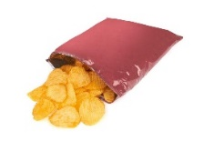 | 3% | PP | 0.6g | 12%
Chocolate bar 40g | Flexible packet  0.8g | 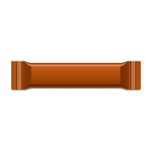 | 5% | PP | 0.16g | 20%
Frozen vegetables  1000g | Flexible pack  3.56g | 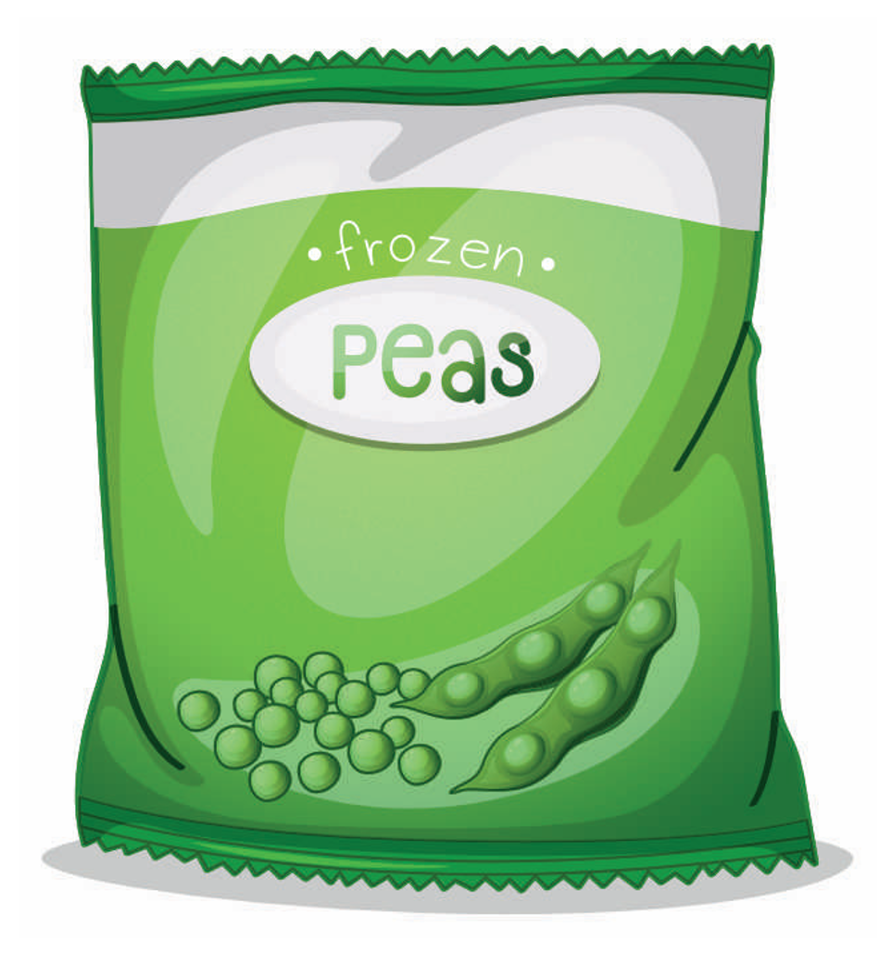 | 0.4% | PE | 0.25g | 7%
Dry rice  500g | Pouch  4.15g | 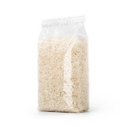 | 0.9% | PE/PET | 0.35g | 8%
Cereals  400g | Stand-up pouch  11g | 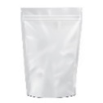 | 2.7% | PE/PET | 0.8g | 7%
Ground coffee  500g | Vacuum pack  7.5g | 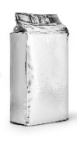 | 1.5% | PE/PET | 0.34g | 5%
Sliced ham  100g | Thermoformed flexible tray and lid  6.9g | 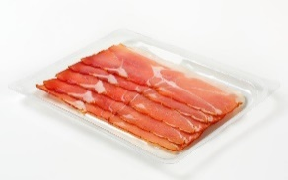 | 6.9% | PE/PET | 0.46g | 7%

Flexible aluminium packaging
Product | Packaging format | Visual | Packaging/product ratio | Structural component(s) | Non-aluminium functional components: inks/lacquer/coating | % Functional components
Chocolate piece (Easter/ Christmas figures)  100g | Aluminium foil wrap  1.4g |  | 1.4% | Aluminium | Inks/lacquer  0.16g | 11%
Yogurt  200g | Lid  0.54g |  | NA | Aluminium | Heat seal lacquer, inks  0.05g | 9%
Spreadable Cheese portion  18g | Folded/lacquered aluminium foil  0.37g | 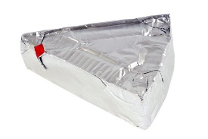 | 2% | Aluminium | Lacquer  0.08g | 21%

Aluminium rigid and semi-rigid packaging
Product | Packaging format | Visual | Packaging/product ratio | Structural component(s) | Non-aluminium functional components: inks/lacquer/coating | % Functional components
Pet food  100g | Aluminium tray + lid  5g | 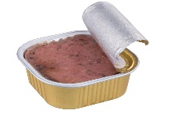 | 5% | Aluminium | Inks/lacquer  0.16g | 15%
Wine  75 cl | Aluminium closure (screw cap)  4.2g |  | NA | Aluminium | Lacquer, inner liner  0.34g | 8%

Annex II - Signatories

See Annex II
Source: Flexible Packaging Europe
Sources: Flexible Packaging Europe (FPE) ; European Aluminium Foil Association (EAFA)
Sources: European Aluminium Foil Association (EAFA); Aluminium Closures Group

